***11 - CONFERENCE MANAGEMENT SYSTEM***

**USECASE DIAGRAM:**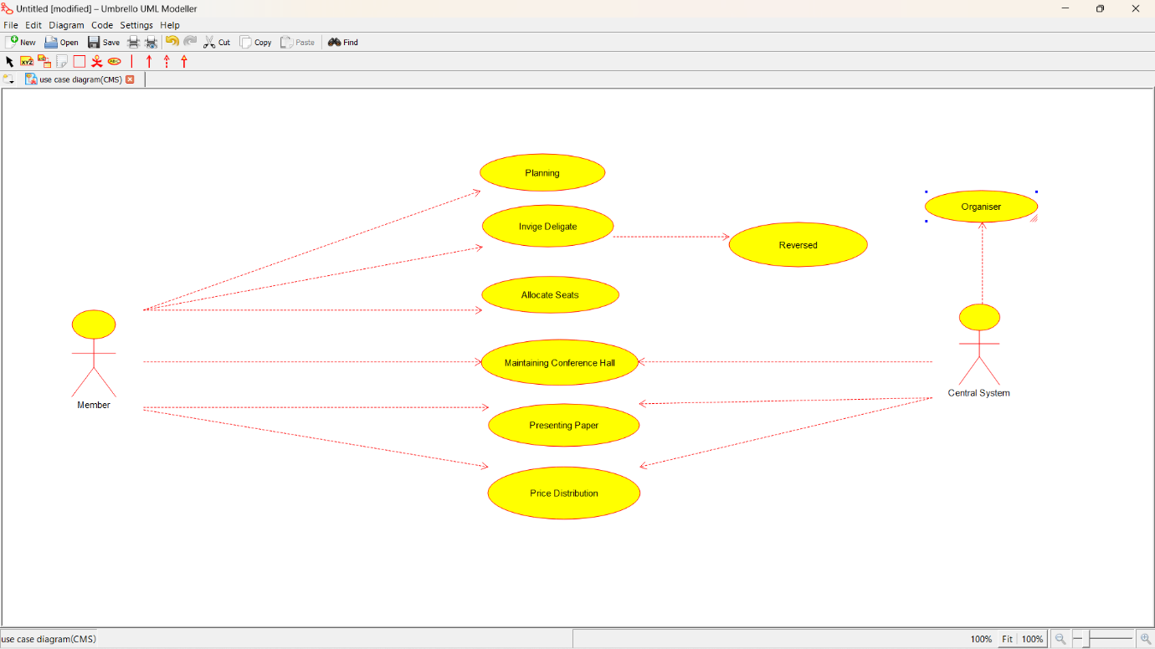

**CLASS DIAGRAM:**

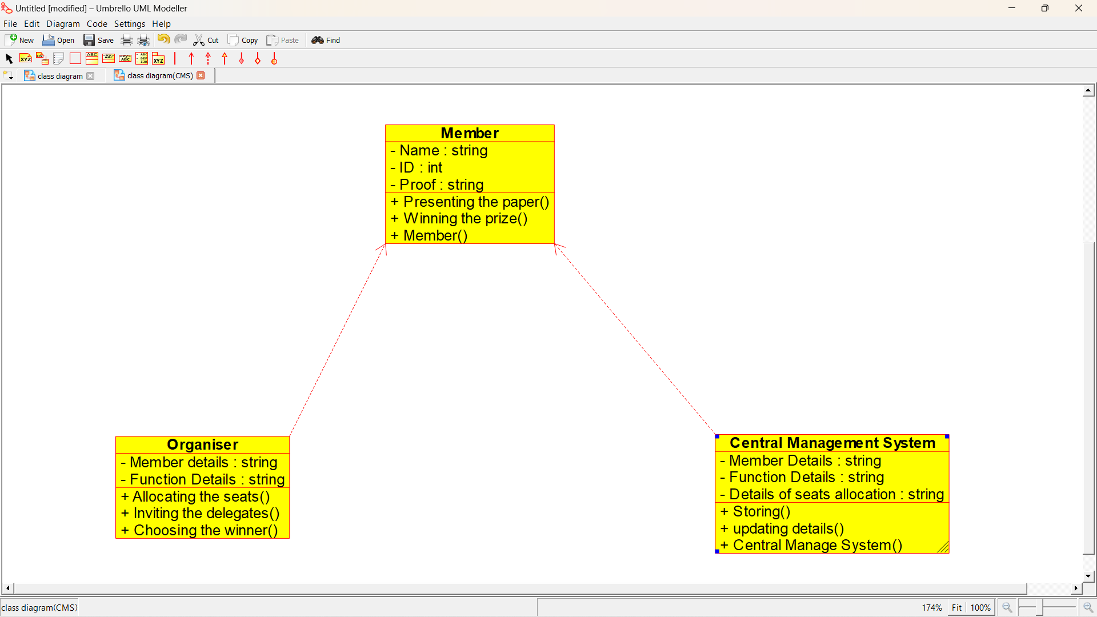

**ACTIVITY DIAGRAM:**

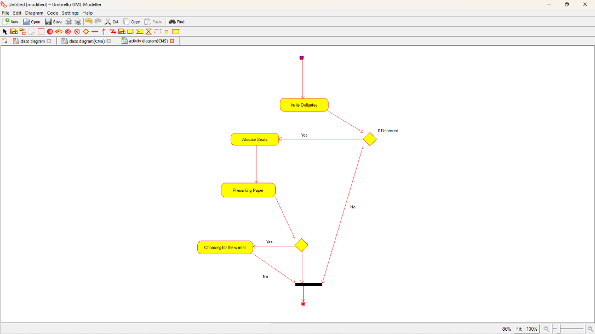

**SEQUENCE DIAGRAM:**

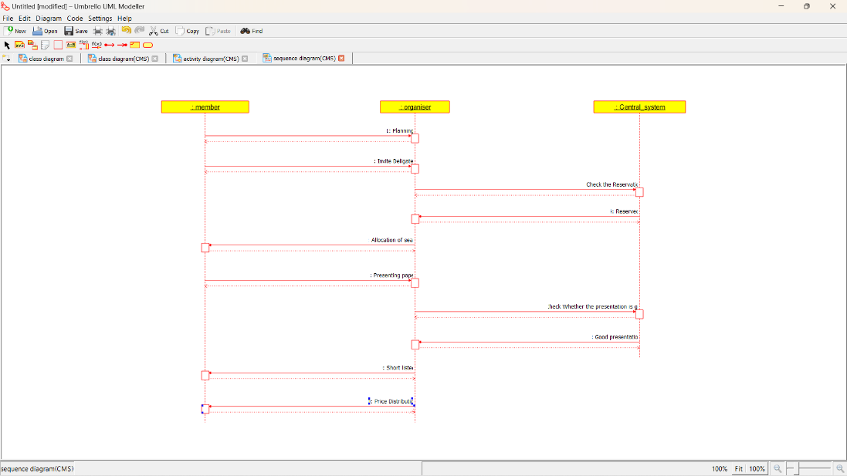

**COLLABORATION DIAGRAM:**

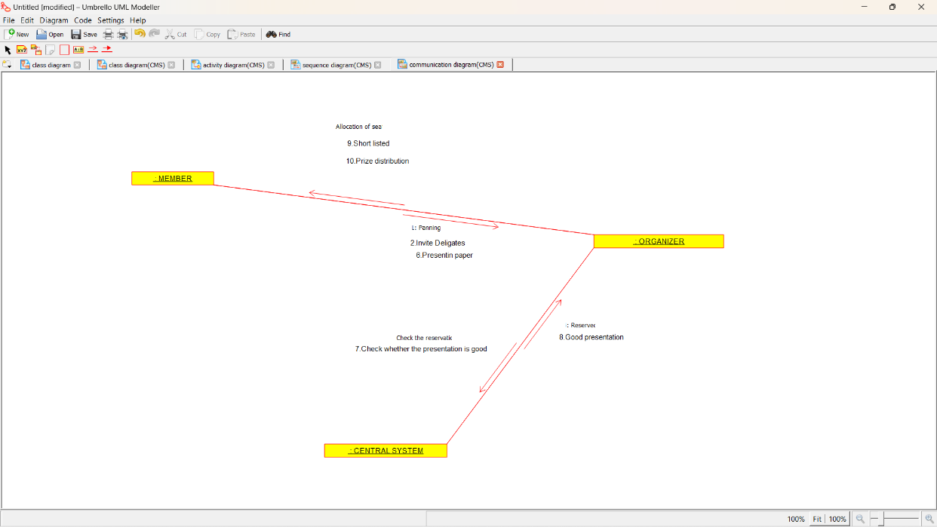

**COMPONENT DIAGRAM:**

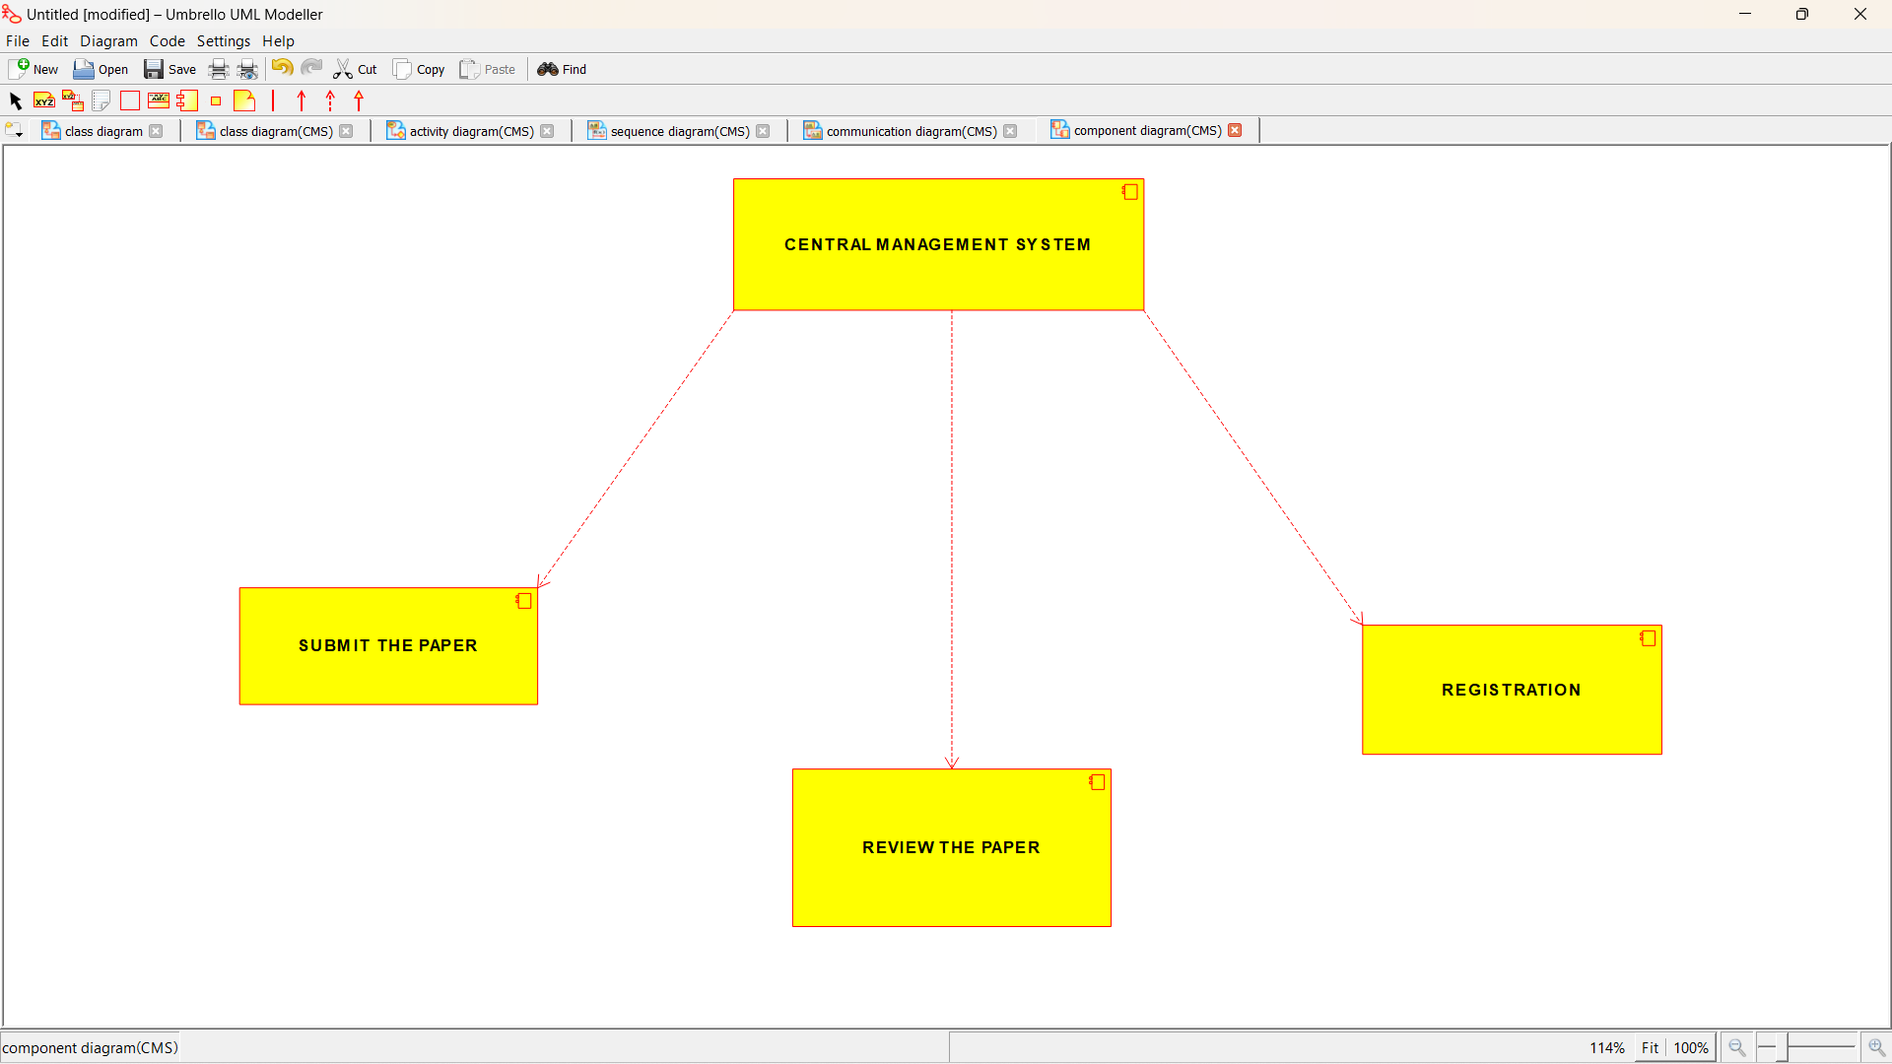

**DEPLOYEMENT DIAGRAM:**

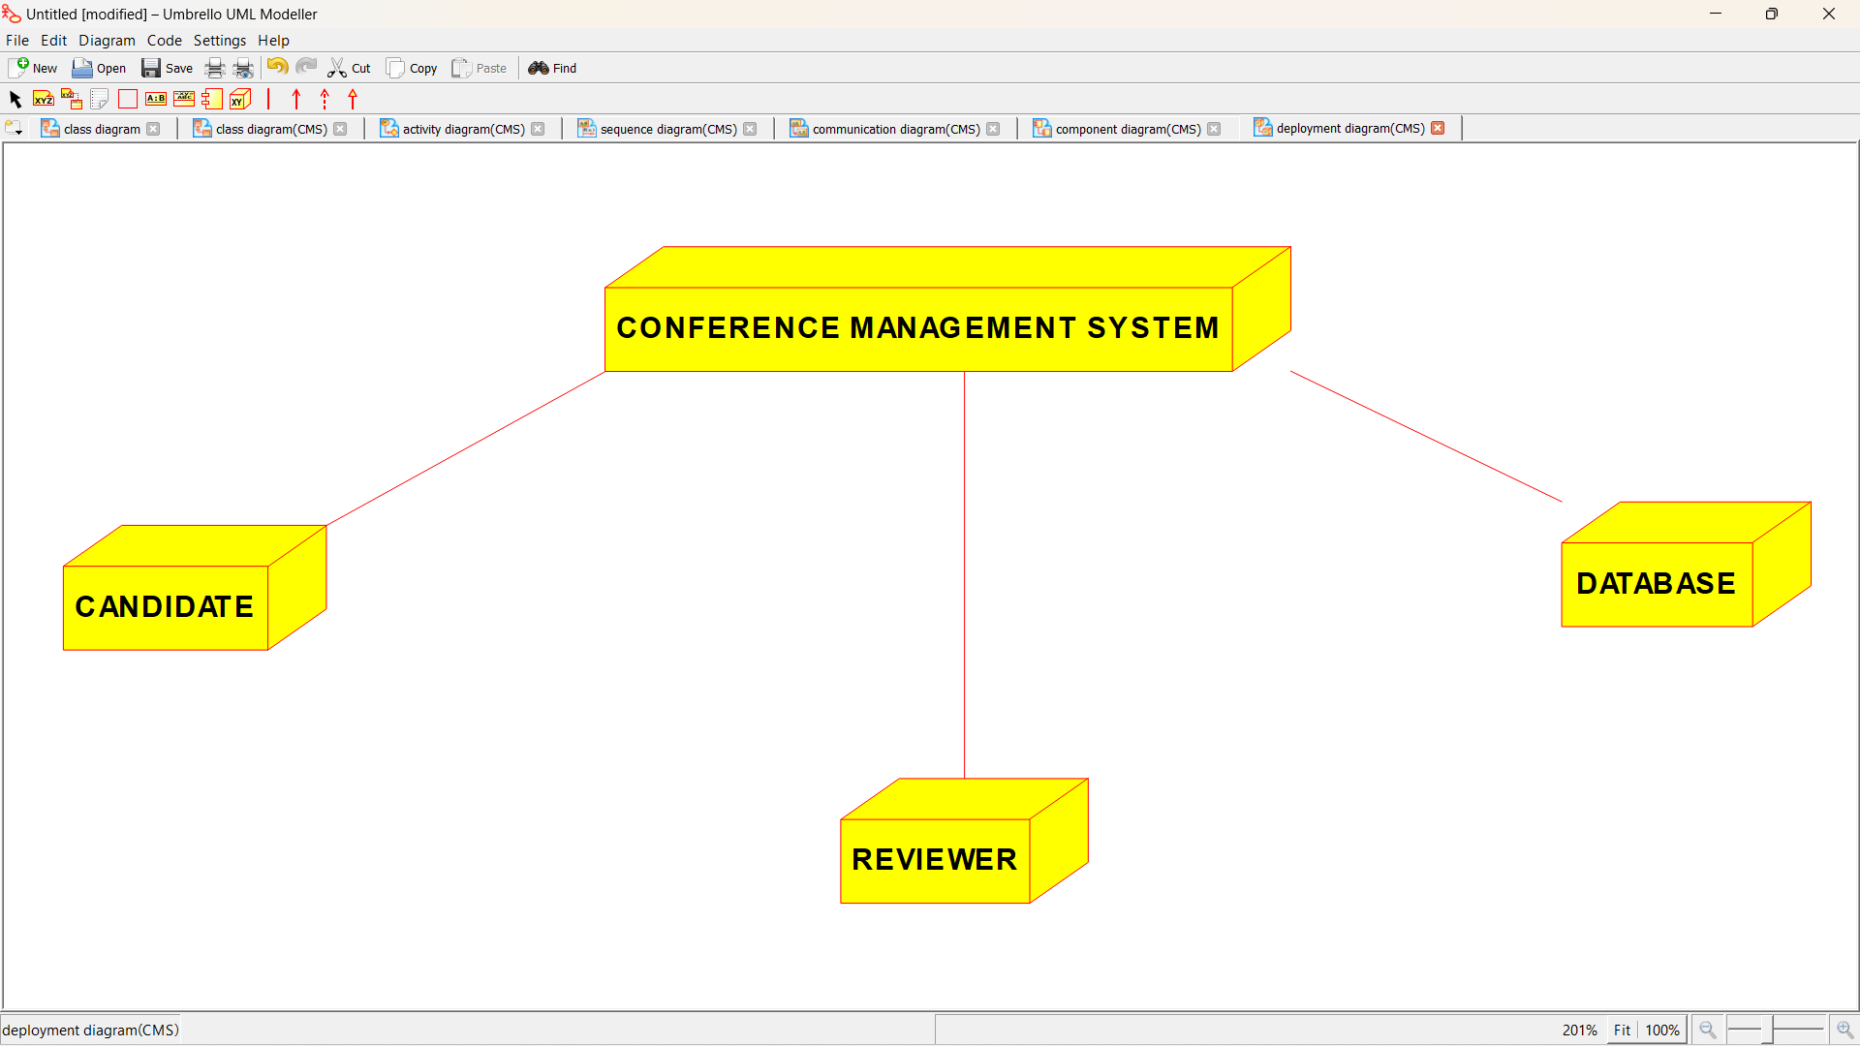

***PROGRAM CODING:***

/**

* Class Central_Management_System

*/

public class Central_Management_System

//

// Fields

//

private String Member_Details;

private String Function_Details;

private String Details_of_seats_allocation;

//

// Constructors

//

public Central_Management_System () { };

//

// Methods

//

//

// Accessor methods

//

/**

* Set the value of Member_Details

* @param newVar the new value of Member_Details

*/

private void setMember_Details (String newVar) {

Member_Details = newVar;

}

/**

* Get the value of Member_Details

* @return the value of Member_Details

*/

private String getMember_Details () {

return Member_Details;

}

/**

* Set the value of Function_Details

* @param newVar the new value of Function_Details

*/

private void setFunction_Details (String newVar) {

Function_Details = newVar;

}

/**

* Get the value of Function_Details

* @return the value of Function_Details

*/

private String getFunction_Details () {

return Function_Details;

}

/**

* Set the value of Details_of_seats_allocation

* @param newVar the new value of Details_of_seats_allocation

*/

private void setDetails_of_seats_allocation (String newVar) {

Details_of_seats_allocation = newVar;

}

/**

* Get the value of Details_of_seats_allocation

* @return the value of Details_of_seats_allocation

*/

private String getDetails_of_seats_allocation () {

return Details_of_seats_allocation;

}

//

// Other methods

//

/**

*/

public void Storing()

{

}

/**

*/

public void updating_details()

{

}

/**

*/

public void Central_Manage_System()

{

}

}

/**

* Class Member

*/

public class Member {

//

// Fields

//

private String Name;

private int ID;

private String Proof;

//

// Constructors

//

public Member () { };

//

// Methods

//

//

// Accessor methods

//

/**

* Set the value of Name

* @param newVar the new value of Name

*/

private void setName (String newVar) {

Name = newVar;

}

/**

* Get the value of Name

* @return the value of Name

*/

private String getName () {

return Name;

}

/**

* Set the value of ID

* @param newVar the new value of ID

*/

private void setID (int newVar) {

ID = newVar;

}

/**

* Get the value of ID

* @return the value of ID

*/

private int getID () {

return ID;

}

/**

* Set the value of Proof

* @param newVar the new value of Proof

*/

private void setProof (String newVar) {

Proof = newVar;

}

/**

* Get the value of Proof

* @return the value of Proof

*/

private String getProof () {

return Proof;

}

//

// Other methods

//

/**

*/

public void Presenting_the_paper()

{

}

/**

*/

public void Winning_the_prize()

{

}

/**

*/

public void Member()

{

}

}

/**

* Class Organiser

*/

public class Organiser {

//

// Fields

//

private String Member_details;

private String Function_Details;

//

// Constructors

//

public Organiser () { };

//

// Methods

//

//

// Accessor methods

//

/**

* Set the value of Member_details

* @param newVar the new value of Member_details

*/

private void setMember_details (String newVar) {

Member_details = newVar;

}

/**

* Get the value of Member_details

* @return the value of Member_details

*/

private String getMember_details () {

return Member_details;

}

/**

* Set the value of Function_Details

* @param newVar the new value of Function_Details

*/

private void setFunction_Details (String newVar) {

Function_Details = newVar;

}

/**

* Get the value of Function_Details

* @return the value of Function_Details

*/

private String getFunction_Details () {

return Function_Details;

}

//

// Other methods

//

/**

*/

public void Allocating_the_seats()

{

}

/**

*/

public void Inviting_the_delegates()

{

}

/**

*/

public void Choosing_the_winner()

{

}

}